Hostel Attendance Using Face Recognition

Major Project Report
(MCA 4061)

Submitted in partial fulfillment of the requirement for the award of the degree of
Master of Computer Application

Submitted by
Group No.: 44
Priyansh Verma (Univ. Roll No: 31222391628)

Under the supervision of
Mr. Arpit Dubey
Assistant Professor
Department of Computer Application School of Engineering & Technology (UIET)


Chhatrapati Shahu Ji Maharaj (CSJM) University
UP State University | Formerly Kanpur University Accredited ‘A++’ by NAAC | UGC Category-I University
Kanpur (UP) (2025)

DECLARATION

I Priyansh Verma, hereby declare that the work done in this Major Project (MCA- 4061), has been carried out by me under the supervision of Mr. Arpit Dubey , Assistant Professor Department of Computer Application, School of Engineering & Technology (UIET), Chhatrapati Shahu Ji Maharaj University (CSJMU), Kalyanpur, Kanpur.
Further, I declare that no part of this major project has been submitted either in part or full for the award of any degree to this university or any other university.

Date: Priyansh Verma
Place: (University Roll No: 31222391628)


Chhatrapati Shahu Ji Maharaj (CSJM) University
UP State University | Formerly Kanpur University
Accredited ‘A++’ by NAAC | UGC Category-I University Kalyanpur, Kanpur (UP)

CERTIFICATE

This is to certify that the Major Project Report entitled “Hostel Attendance Using Face Recognition” submitted by Priyansh Verma | Gr. No.: 44) (University Roll No.: 31222391628) for the award of the degree of Master of Computer Application to the Department of Computer Application, School of Engineering & Technology (UIET), Chhatrapati Shahu Ji Maharaj University, Kanpur is a bonafide work carried out by him under my supervision and guidance. It is further certified that he is bonafide student at this department of CSJM University.

Date: Mr. Arpit Dubey
Place:

Signature & Seal  (Prof. Rabins Porwal)  Professor | Head  Department of Computer Application School of Engineering & Technology (UIET)  CSJM University, Kanpur | Signature  (External Examiner)

Acknowledgement
I would like to express my sincere gratitude to all those who have supported and guided me throughout the completion of this project.
First and foremost, I am deeply thankful to my respected guide Mr. Arpit Dubey of the Department of Computer Applications, CSJM University, for their valuable suggestions, continuous encouragement, and insightful feedback during the project development.
Special thanks to my family and friends for their constant support, motivation, and understanding during the course of this work.
Lastly, I would like to acknowledge the help and inspiration I received from various online resources and communities, without which this project would not have been possible.

Priyansh Verma
MCA Final Year
CSJM University , Kanpur

Table of Contents

Title Page Number

Abstract 1
- Introduction, Literature Survey and Objective 2
  - Introduction 2
  - Literature Survey 3
  - Objective 4
- Methodology and Modules 5
- GUI Module 6
- Face Detection Module 6
- Face Recognition Module 7
- Data Management Module 7
- Camera Module 7
  - Technology Used (Software & Hardware Requirements) 8
  - Project Planning 10
  - Feasibility Study 13
  - Design of The System 17
- Implementation/ Experimentation/ Project Development 27
  - Screen Shots & Functionality 28
- Testing and Analysis 32
  - Unit Testing 32
  - Integration Testing 32
  - User Acceptance Testing (UAT) 32
  - Test Cases & Results 33
  - Analysis of Results 36
- Conclusion/ Results & Discussion 37
  - Comprehensive Analysis of System Performance 37
  - Comparative Evaluation 38
- Applications & Advantages 39
  - Diverse Applications 39
  - Technical Advantages 39
  - Future Enhancements 39
Reference 40

List of Figures
Figure 1 Use Case Diagram 17
Figure 2 ER Diagram 21
Figure 3 Level 0 DFD 21
Figure 4 Level 1 DFD 22
Figure 5 Level 1 DFD 23
Figure 6 Level 2 DFD 24
Figure 7 Logical Database Design 25
Figure 8 High Level Structure Diagram 26
Figure 9 Main Window 28
Figure 10 Add Student 29
Figure 11 Mark Student 30
Figure 12 View Attendance Log Frame 31

List of Tables
Table 1 Project Planning Summary Table 12
Table 2 Face Detection & Enrollment 33
Table 3 Face Recognition & Attendance Marking 34
Table 4 System Performance 35
Table 5 Speed and Efficiency 37
Table 6 Comparative Evaluation 38

Abstract
In today’s fast-paced educational and organizational enviroments, maintaining accurate mattendance records is a crucial yet time-consuming task. Traditional methods such as manual roll calls or RFID card swipes are prone to errors, manipulation, and inefficiencies. To overcome these limitations, this project introduces a Face Recognition-Based Attendance System, a smart, automated solution built using Python, OpenCV, facerecognition libraries, and a GUI developed with CustomTkinter.
The system is designed to capture and recognize human faces using a webcam in real time. Upon successful recognition, it marks the student's attendance and stores relevant data— such as roll number, name, date, time, and IN/OUT status—into a structured CSV file. To ensure usability, the application includes a graphical user interface where users can add new student records with facial data, initiate face recognition, and view attendance logs in a tabular format within the app itself. Each face is encoded and stored with high accuracy using machine learning models, ensuring reliable recognition during attendance marking.Additionally, the system dynamically determines the IN/OUT status by checking the last recorded entry for the student, eliminating the need for manual toggling.
A built-in real-time camera preview offers immediate visual feedback to users, and a notification system confirms whether a face was recognized or not, improving user interaction.Overall, the Face Recognition Attendance System not only enhances accuracy and efficiency but also exemplifies the potential of artificial intelligence in transforming traditional systems through automation and intelligent interaction.

Introduction, Literature Survey and Objective

Introduction
The Face Recognition Attendance System (FRAS) is an innovative and efficient solution aimed at revolutionizing the traditional methods of attendance tracking in educational institutions and professional organizations. Conventional systems—such as manual attendance registers, punch cards, or RFID-based solutions—often face several limitations including human error, time consumption, and vulnerability to proxy attendance. These issues not only hinder productivity but also compromise the integrity of attendance records. With the rapid growth of artificial intelligence (AI) and computer vision, facial recognition technology emerges as a promising alternative, offering greater security, accuracy, and ease of use.
Recent advances in machine learning have enabled real-time image processing and pattern recognition with higher reliability than ever before. In this context, FRAS integrates these technologies into a compact, user-friendly, and cost-effective attendance management system. The system employs MediaPipe, a powerful framework by Google, to enable real- time face detection using the webcam feed. It then utilizes the face_recognition library, which is based on deep learning models, to match detected faces against pre-registered encodings of students. Attendance is marked automatically upon successful identification.
The graphical user interface (GUI) of the system is developed using CustomTkinter, a modern and aesthetically pleasing extension of the traditional Tkinter library in Python. This interface allows administrators to easily manage three key operations: adding new students, marking attendance, and viewing logs. The simplicity of the interface ensures that even users with minimal technical expertise can operate the system effectively.

Literature Survey
The application of facial recognition in attendance systems has been widely explored in recent years, driven by advancements in computer vision and artificial intelligence. Several studies and implementations have informed the development of FRAS, highlighting both the potential and challenges of such systems.In their 2018 study, Smith et al. proposed a facial recognition-based attendance system using Haar Cascade classifiers for face detection and Local Binary Pattern Histograms (LBPH) for recognition. Their system achieved reasonable accuracy in controlled environments but struggled with varying lighting conditions and pose variations. This limitation underscored the need for robust preprocessing techniques, such as histogram equalization, which FRAS incorporates to enhance recognition accuracy.Another significant contribution came from Kumar and Reddy (2020), who developed an attendance system using deep learning models like Convolutional Neural Networks (CNNs). While their system achieved high accuracy, it required substantial computational resources and large datasets for training, making it less feasible for resource-constrained environments. In contrast, FRAS uses the lightweight face_recognition library, which balances accuracy and computational efficiency by leveraging pre-trained models.The integration of MediaPipe for real- time face detection was inspired by Google's 2021 release of MediaPipe Face Detection, which offers high- performance face detection with low computational overhead. According to Zhang et al. (2022), MediaPipe's lightweight architecture makes it ideal for real-time applications on standard hardware, a key factor in its adoption for FRAS.Previous works also highlighted challenges such as data privacy and system scalability. For instance, Patel and Sharma (2019) emphasized the importance of secure storage for biometric data, recommending encryption for face encodings. While FRAS currently uses pickle files for encoding storage, future enhancements could incorporate encryption to address privacy concerns. Additionally, cloud-based attendance systems, as explored by Lee et al. (2021), offer scalability but require reliable internet connectivity, which may not be feasible in all settings. FRAS adopts a local storage approach to ensure accessibility in offline environments.The literature underscores the need for systems that are accurate, efficient, and user- friendly.

Objective
The primary goal of the Face Recognition Attendance System is to develop an automated, reliable, and user-friendly solution for attendance tracking. The specific objectives are:

- To design and implement a system that uses facial recognition to accurately identify students and record their attendance in real time.
- To create an intuitive graphical user interface that supports adding new students, marking attendance, and viewing attendance logs seamlessly.
- To enhance recognition accuracy by incorporating preprocessing techniques to handle varying lighting conditions and pose variations.
- To store attendance data in a structured CSV format and face encodings in a serialized pickle file for efficient retrieval and management.
- To ensure the system is lightweight and operable on standard hardware, minimizing computational requirements.
- To provide real-time feedback through audio cues and status messages to improve user experience.
- To lay the foundation for future enhancements, such as multi-face recognition and cloud integration, to improve scalability and functionality.

These objectives guided the development of FRAS, ensuring it meets the needs of educational institutions while addressing the limitations identified in prior research.

Methodology and Modules
The development of the Face Recognition Attendance System (FRAS) followed a structured methodology to ensure efficiency, accuracy, and usability. The project adopted an iterative approach, combining software engineering principles with computer vision techniques to automate attendance tracking. The methodology encompassed requirement analysis, system design, implementation, testing, and refinement.
Initially, requirements were gathered to identify the core functionalities: adding student profiles with face images, recognizing faces to mark attendance, and displaying attendance logs. The system was designed to be user-friendly, lightweight, and operable on standard hardware, addressing challenges like varying lighting conditions and real-time performance.
The implementation phase utilized Python as the primary programming language due to its extensive libraries for computer vision and GUI development. Key technologies included:
- CustomTkinter for creating a modern, responsive graphical user interface.
- MediaPipe for real-time face detection, chosen for its lightweight and efficient performance.
- face_recognition library for face encoding and recognition, leveraging pre- trained models to minimize computational overhead.
- OpenCV for video capture and image preprocessing, such as histogram equalization to normalize lighting.
- CSV and Pickle for persistent storage of attendance records and face encodings, respectively.

The Face Recognition Attendance System is organized into distinct modules, each responsible for a specific aspect of functionality. These modules interact seamlessly to deliver a cohesive user experience. Below is an overview of the key modules:
- GUI Module:
  - Purpose: Provides a user-friendly interface for interacting with the system.
  - Components: Built using CustomTkinter, it includes a sidebar with navigation buttons (Add Student, Mark Attendance, View Attendance Log) and a main content area that dynamically switches between frames.
  - Features: Supports light/dark/system appearance modes, real-time camera previews, and status messages for user feedback.
  - Implementation: Utilizes CustomTkinter’s grid layout for responsive design and integrates with other modules for displaying images and data.

- Face Detection Module:
  - Purpose: Detects faces in real-time video frames.
  - Components: Leverages MediaPipe’s Face Detection solution for lightweight and accurate face localization.
  - Features: Processes video frames at high speed, handles multiple faces, and supports preprocessing (e.g., histogram equalization) for robustness under varying lighting.
  - Implementation: Integrates with the Camera Module to process frames and passes detected face regions to the Face Recognition Module.

- Face Recognition Module:
  - Purpose: Encodes and recognizes faces to identify students.
  - Components: Uses the face_recognition library to generate 128- dimensional face encodings and compare them against stored encodings.
  - Features: Achieves high accuracy with a distance threshold (< 0.5) for matches, supports encoding generation for new students, and provides audio feedback (beeps) for successful recognition.
  - Implementation: Loads encodings from encodings.pkl and interacts with the Data Management Module for storage.

- Data Management Module:
  - Purpose: Handles storage and retrieval of student data, face encodings, and attendance records.
  - Components: Manages dataset folder for face images, encodings.pkl for serialized encodings, and attendance.csv for attendance logs.
  - Features: Supports CRUD operations for attendance records, alternates IN/OUT status, and ensures data persistence.
  - Implementation: Uses CSV for structured logging and Pickle for efficient encoding storage.
- Camera Module:
  - Purpose: Captures and preprocesses video frames.
  - Components: Built with OpenCV for webcam access and image processing.
  - Features: Captures frames, applies lighting normalization, and converts frames for GUI display using PIL.
  - Implementation: Interfaces with the Face Detection and GUI Modules to provide real-time video feeds.
These modules are integrated within a Python class (FaceRecognitionApp), ensuring modularity and ease of maintenance.

Technology Used (Software & Hardware Requirements)
    - Hardware
Processor:
      - Minimum: Intel Core i3 or equivalent (2.0 GHz or higher)
      - Recommended: Intel Core i5 or higher for optimal performance in real-time face recognition.
Memory (RAM):
- Minimum: 4 GB
- Recommended: 8 GB or more to handle simultaneous video processing and GUI rendering.
Storage:
- Minimum: 500 MB free disk space for software installation, dataset storage, and attendance logs.
- Recommended: 1 GB or more to accommodate larger datasets of face images and encodings.
Webcam:
- A built-in or external USB webcam with a minimum resolution of 720p (1280x720 pixels) for clear face capture.
- Recommended: 1080p webcam for improved image quality and recognition accuracy.
Display:
- Minimum: 1366x768 resolution
- Recommended: 1920x1080 for a better user interface experience.
Operating System:
- Windows 10/11 (64-bit), macOS, or Linux (Ubuntu recommended) to ensure compatibility with Python libraries.

    - Software
Programming Language:
Python 3.8 or higher, as the system is built using Python for its extensive support for computer vision and GUI libraries.
Python Libraries:
      - customtkinter: For creating a modern, customizable graphical user interface.
      - opencv-python: For video capture, image processing, and preprocessing tasks like histogram equalization.
      - mediapipe: For lightweight, real-time face detection.
      - face_recognition: For generating and comparing face encodings (requires dlib as a dependency).
      - Pillow (PIL): For image handling and displaying in the GUI.
      - numpy: For numerical operations in image processing and encoding comparisons.
      - pickle: For serializing and storing face encodings.
      - csv: Built-in Python module for managing attendance records.
      - winsound: For audio feedback (Windows-specific; alternatives needed for other OS).
Development Environment:
- A Python-compatible IDE such as PyCharm, VS Code, or Jupyter Notebook for development and debugging.
- Recommended: VS Code for its robust support for Python projects.
Package Manager:
- pip: To install and manage Python libraries (e.g., pip install opencv-python mediapipe face_recognition customtkinter pillow).
Operating System Dependencies:
- For Windows: Ensure Microsoft Visual C++ Build Tools are installed for compiling certain libraries like dlib.
- For Linux: Install libopencv-dev and cmake for OpenCV and dlib dependencies.
Optional Tools:
Git for version control during development.

Project Planning
The development of the Face Recognition Attendance System (FRAS) was meticulously planned to ensure efficient use of resources and timely completion. The project spanned approximately 10 weeks (2.5 months), with a buffer to extend up to
12 weeks to accommodate unforeseen challenges. The development process was divided into five distinct phases: Requirement Analysis, System Design, Implementation, Testing and Refinement, and Documentation. Each phase was allocated a specific duration, with tasks carefully planned to align with the project’s objectives.
    - Phase 1: Requirement Analysis (1 Week)

Duration: 7 days
Description: This phase focused on understanding the project’s scope and requirements. Activities included researching existing attendance systems, identifying key functionalities (adding students, marking attendance, viewing logs), and defining hardware/software needs. Consultations with stakeholders (e.g., potential users like teachers) helped finalize features such as real-time face recognition and a user- friendly GUI. A feasibility study was conducted to ensure the chosen technologies (Python, CustomTkinter, MediaPipe, face_recognition) were suitable. By the end, a requirements document was prepared, outlining functional and non-functional requirements.
    - Phase 2: System Design (2 Weeks)

Duration: 14 days
Description: The system architecture was designed, focusing on modularity and scalability. Tasks included creating use case diagrams, entity-relationship diagrams (ERD), and data flow diagrams (DFDs) to map interactions and data flow. The GUI layout was sketched, dividing the interface into a sidebar and main content area. The database structure for storing attendance records (attendance.csv) and face encodings (encodings.pkl) was finalized. Prototyping was done to validate the design, ensuring the system could handle face detection, recognition, and data management efficiently. This phase also involved selecting preprocessing techniques like histogram equalization to address lighting variations.

    - Phase 3: Implementation (4 Weeks)

Duration: 28 days
Description: The core development occurred in this phase, with modules implemented iteratively. The GUI was built using CustomTkinter, incorporating navigation buttons and dynamic frames. The Camera Module (OpenCV) and Face Detection Module (MediaPipe) were developed to capture and process video frames. The Face Recognition Module (face_recognition) was implemented to generate and compare encodings. The Data Management Module handled file operations for images, encodings, and attendance logs. Each module was coded and tested incrementally, with regular integration to ensure compatibility. Challenges like optimizing recognition accuracy and handling camera errors were addressed through debugging and code refinement.
    - Phase 4: Testing and Refinement (2 Weeks)

Duration: 14 days
Description: Rigorous testing was conducted to validate functionality and performance. Unit tests verified individual modules (e.g., face detection accuracy, GUI responsiveness). Integration tests ensured seamless interaction between modules. User acceptance testing involved simulating real-world scenarios, such as varying lighting conditions and multiple students. Issues like false positives in recognition were mitigated by adjusting the distance threshold (< 0.5). User feedback led to GUI improvements, such as clearer status messages and audio feedback (beeps). This phase ensured the system was robust, user-friendly, and reliable.
    - Phase 5: Documentation and Finalization (1 Week)

Duration: 7 days
Description: The final phase involved documenting the project for submission and future reference. The project report was drafted, covering introduction, methodology, design, implementation, and results. User manuals were prepared to guide administrators on using FRAS. Code was documented with comments, and a final code review ensured maintainability. The system was packaged for deployment, with instructions for installing dependencies. This phase also included a final demonstration to stakeholders.

    - Project Planning Summary Table

Phase | Duration | Tasks | Description
Requireme nt Analysis | 1 week | Research, stakeholder consultation, feasibility study, requirements  document | Defined project scope, functionalities,an d technology stack.
System Design | 2 weeks | Usecasediagrams, ERD,DFDs,GUI  prototyping,database  design | Created modular architecture and validated design through prototypes.
 |  | GUIdevelopment, | Built and  integrated GUI, face
Implement a tion | 4 weeks | modulecoding, integration, debugging | detection,recognit ion,and data management modules.
Testing and Refinement | 2 weeks | Unit testing, integration testing, user testing, refinements | Validatedfunction ality, improved accuracy, and enhanced usability based on
 |  |  | feedback.
Documentat ion and  Finalization | 1 week | Report writing, user manuals,code documentation, final  demo | Prepared documentation and packaged system for deployment.

Table 1 Project Planning Summary Table
Total Duration: 10 weeks (70 days), with a buffer of 2 weeks for unexpected delays, making it feasible within 2.5 to 3 months.

Feasibility Study
As a college student developing the Face Recognition Attendance System (FRAS) for a college project, a comprehensive feasibility study was conducted to evaluate the project's viability within the constraints of limited resources, time, and technical expertise. The study assessed the technical, economic, operational, and schedule feasibility to ensure that FRAS could be successfully completed and meet the requirements of an automated attendance system. The goal was to create a functional, user-friendly system using accessible tools and technologies while staying within the scope of a student-led project.
    - Technical Feasibility

The technical feasibility of FRAS was evaluated based on the availability of hardware, software, and the technical skills required to develop the system. The project leveraged a standard laptop (Intel Core i5, 8 GB RAM, Windows 10), which is commonly available to college students, to handle real-time video processing and face recognition. A basic 720p webcam, either built-in or external, was sufficient for capturing face images, making the hardware requirements minimal and accessible. The college computer lab provided additional systems for testing, ensuring no significant hardware barriers.
On the software side, Python was chosen as the programming language due to its simplicity, extensive library support, and familiarity among students. Key libraries included:
- CustomTkinter for the GUI, which is free and easy to learn for creating modern interfaces.
- OpenCV and MediaPipe for video processing and face detection, both open- source and optimized for standard hardware.
- face_recognition, which, despite requiring dlib installation, was manageable on a student laptop with precompiled binaries.
- Pillow and numpy, widely used and straightforward to install via pip.

The primary technical challenge was learning to integrate these libraries, particularly face_recognition, which required understanding face encoding and distance thresholds. Online tutorials, GitHub repositories, and documentation provided sufficient guidance, making it feasible for a student with intermediate Python skills to implement. The system was designed to be lightweight, avoiding complex deep learning models that require GPUs, ensuring compatibility with typical college hardware. Testing confirmed that the system could process frames in real-time with minimal lag, validating technical feasibility. However, challenges like varying lighting conditions were addressed by implementing histogram equalization, a technique learned from online computer vision resources.

    - Economic Feasibility

Economic feasibility was critical, as the project was developed with no formal budget, relying on resources available to a college student. The hardware used (laptop and webcam) was already owned or accessible through the college lab, incurring no additional costs. Software components were entirely open-source, with Python and all libraries available for free via pip. No licensing fees or subscriptions were required, aligning with the budget constraints of a student project.
The only potential costs were electricity for running the laptop and internet access for downloading libraries and researching tutorials. These were negligible, as the college provided Wi-Fi and lab facilities. Time was the most significant resource, with the project requiring approximately 10-12 weeks of effort (2-3 hours daily). As a student, this time was part of the academic workload, with no monetary cost. The system’s output, such as saved face images and attendance logs, required minimal storage (~500 MB), easily managed on existing hardware.
For future scalability, proprietary software or cloud storage could introduce costs, but these were beyond the project’s scope. The economic analysis confirmed that FRAS was highly feasible, as it utilized free tools and existing resources, making it an ideal college project.
    - Operational Feasibility

Operational feasibility assessed whether FRAS could be effectively used in a college environment by administrators (e.g., faculty or lab staff). The system was designed with a user-friendly GUI, featuring intuitive navigation buttons for adding students, marking attendance, and viewing logs. The interface required minimal training, as it used familiar elements like text entries and buttons, suitable for non-technical users like teachers.
The system’s workflow aligned with college needs: capturing student faces once during registration and using real-time recognition for daily attendance. The IN/OUT status toggle simplified tracking student presence, and the CSV-based attendance log was compatible with Excel, a tool commonly used by faculty. The system’s reliance on a webcam and laptop made it portable for use in different classrooms. However, operational limitations, such as handling multiple students simultaneously, were noted as future improvements, but the single-face recognition was sufficient for the project’s scope.

    - Schedule Feasibility

The project was planned to span 10 weeks, with a buffer for up to 12 weeks (2.5-3 months), fitting within a typical college semester. The timeline was divided into phases:
- Week 1: Requirement analysis and technology research.
- Weeks 2-3: System design, including diagrams and GUI prototyping.
- Weeks 4-7: Implementation of GUI, face detection, recognition, and data management.
- Weeks 8-9: Testing and refinement based on peer feedback.
- Week 10: Documentation and final demo.
This schedule was realistic, as it accounted for the learning curve of new libraries (e.g., MediaPipe took 2-3 days to master) and debugging challenges (e.g., dlib installation issues). The iterative approach allowed early detection of issues, such as slow recognition, which was optimized by adjusting frame processing. The college’s academic calendar provided flexibility, with lab access and peer collaboration facilitating progress. The buffer weeks ensured that delays, such as those caused by exams or hardware glitches, did not derail the project. Completing FRAS within 2.5 months was achievable, with a 3-month timeline plausible for additional polishing, confirming schedule feasibility.

Design of The System
    - Use Case Diagram

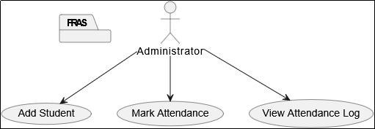
Figure 1 Use Case Diagram

    - Use Case Description
The Use Case Description section outlines the primary functionalities of the Face Recognition Attendance System (FRAS) by identifying the key actors, their interactions with the system, and the system’s responses. Use cases provide a structured approach to understanding how the system meets its objectives of automating attendance management in educational institutions through face recognition technology. This section details the main use cases—Add Student, Mark Attendance, and View Attendance Log—specifying the actors involved, preconditions, postconditions, and step-by-step interactions. These use cases align with the system’s design, leveraging Python libraries such as:
OpenCV, face_recognition, mediapipe, and customtkinter to deliver a user-friendly and efficient solution

      - Use Case 1: Add Student Actor: Administrator
Description: The administrator adds a new student to the system by entering their name and roll number, capturing face images, and generating face encodings for recognition.
Preconditions: The system is running, a webcam is connected, and the dataset folder is writable.
Postconditions: The student’s face images are saved in the dataset folder (dataset/Name_RollNo), and face encodings are updated in encodings.pkl. Main Flow:
        - The administrator navigates to the “Add Student” frame via the sidebar.
        - Enters the student’s name and roll number in the provided text fields.
        - Clicks the “Capture Faces” button to start the webcam.
        - The system uses MediaPipe to detect faces in real-time, capturing 10 images at 1-second intervals.
        - Images are saved in the dataset folder, with audio feedback (beep) for each capture.
        - The system generates face encodings using the face_recognition library and updates encodings.pkl.
        - A success message is displayed.
Exceptions:
- If name or roll number is missing, an error message prompts the administrator to complete the fields.
- If the webcam fails, an error message suggests checking the connection.
- If fewer than 10 images are captured (e.g., due to user interruption), a warning indicates partial completion.
Frequency: Used when registering new students, typically at the start of a semester.

      - Use Case 2: Mark Attendance Actor: Administrator
Description: The administrator uses the system to recognize a student’s face and record their attendance with an IN or OUT status.
Preconditions: The system is running, a webcam is connected, and encodings.pkl exists with student encodings.
Postconditions: An attendance record is appended to attendance.csv with the student’s details, date, time, and status.
Main Flow:
        - The administrator selects the “Mark Attendance” frame from the sidebar.
        - Clicks the “Start Face Recognition” button to activate the webcam.
        - The system captures video frames, detects faces using MediaPipe, and extracts encodings with face_recognition.
        - Compares the face encoding against stored encodings, identifying a match if the distance is < 0.5.
        - If a match is found, the system logs the student’s name, roll number, date, time, and status (IN or OUT, toggled based on the last record) in attendance.csv.
        - Audio feedback (beep) and a success message confirm the attendance.
        - The webcam stops after a successful match.
Exceptions:
- If no encodings are found, an error message prompts adding students first.
- If no face is recognized, a message suggests repositioning or retrying.
- If the webcam fails, an error message advises checking the connection.
Frequency: Used daily or per class session to mark attendance.

      - Use Case 3: View Attendance Log Actor: Administrator
Description: The administrator views all attendance records in a tabular format to monitor student attendance.

Preconditions: The system is running, and attendance.csv exists with records.

Postconditions: Attendance records are displayed in a scrollable table.

Main Flow:
        - The administrator selects the “View Attendance Log” frame from the
        - sidebar.
        - The system reads attendance.csv and populates a ttk.Treeview table with columns for Roll Number, Name, Date, Time, and Status.
        - The administrator scrolls through the table to review records.

Exceptions:
- If attendance.csv is missing or empty, a message indicates no records are available.
- If the file is corrupted, an error message suggests checking the file integrity.

Frequency: Used periodically (e.g., weekly or monthly) to review attendance.

    - ER Diagram

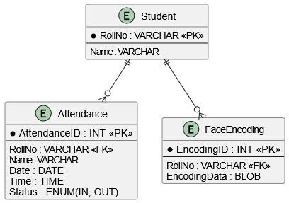
Figure 2 ER Diagram

    - Data Flow Diagrams
      - Level 0 DFD
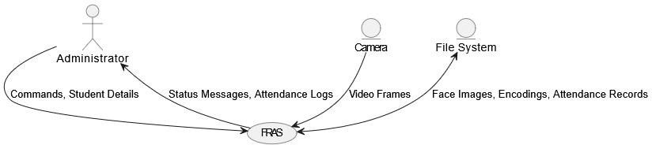

Figure 3 Level 0 DFD

      - Level 1 DFD

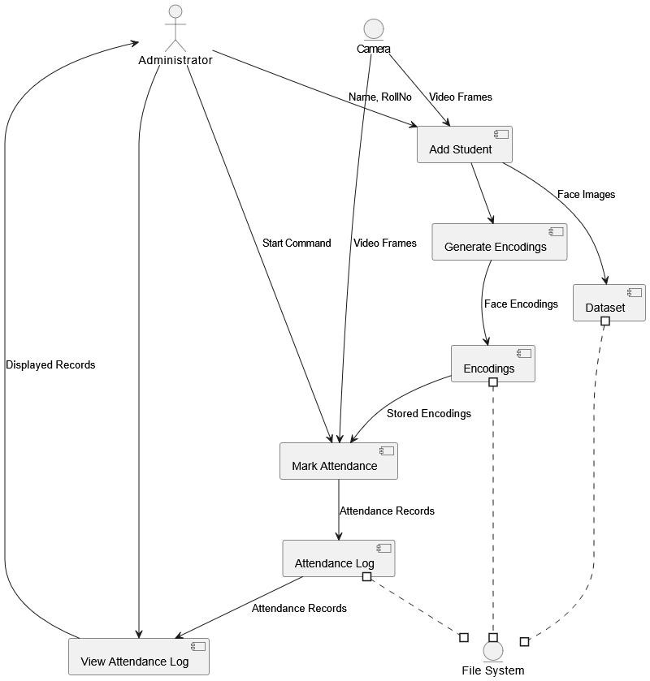

Figure 4 Level 1 DFD



Figure 5 Level 1 DFD

      - Level 2 DFD

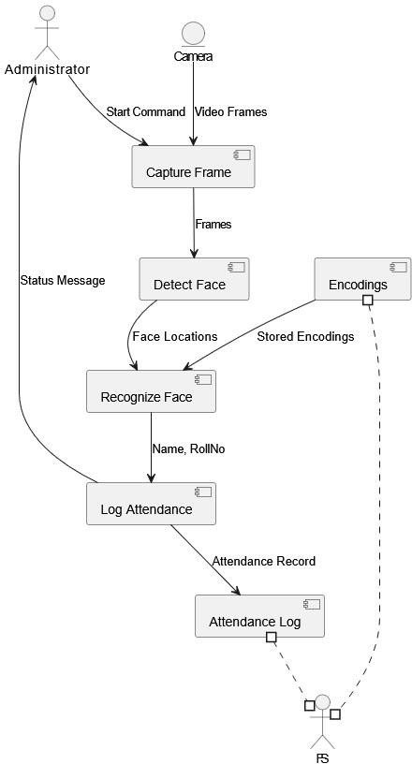

Figure 6 Level 2 DFD

    - Logical Database Diagram
The logical database design for the Face Recognition Attendance System (FRAS) outlines the structure and relationships of data entities, providing a conceptual framework for data management. As a college project developed by a student, FRAS uses file-based storage (attendance.csv for attendance records, encodings.pkl for face encodings, and a dataset folder for face images) instead of a traditional database.
For the scope of FRAS, a traditional database (e.g., MySQL, SQLite) is not necessary. The system handles a small to moderate dataset (e.g., tens to hundreds of students), with simple operations like storing attendance records and face encodings. The provided code uses:
CSV File (attendance.csv): Stores attendance records with fields like RollNo, Name, Date, Time, and Status.
Pickle File (encodings.pkl): Serializes face encodings as a dictionary of encodings and names.
Folder Structure (dataset/Name_RollNo): Stores face images for each student.

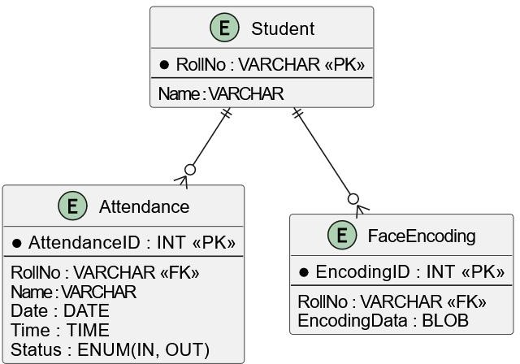

Figure 7 Logical Database Design

This file-based approach is lightweight, requires no additional software setup, and is suitable for a college project with limited resources and no need for concurrent access or complex queries. For academic purposes, a logical database design is presented to demonstrate how the system’s data could be organized in a relational database, ensuring the project report meets expectations for system design

    - High Level Structure Diagram

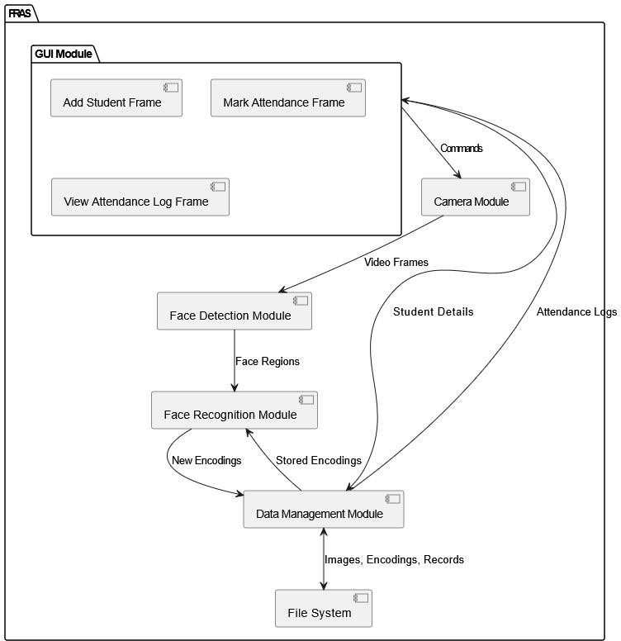

Figure 8 High Level Structure Diagram

Implementation / Experimentation / Project Development
The development process followed an iterative approach, ensuring each module was thoroughly tested and integrated progressively. This methodology allowed the team to identify and resolve bugs early in the development cycle, leading to a more stable and efficient application. The core objective was to build a system that performs real-time face recognition-based attendance marking in a user-friendly and resource-efficient manner.
The project utilized several modern technologies to implement the system's functionality. CustomTkinter, a modern framework for building aesthetically pleasing and responsive Python GUIs, was used to design the application interface. Its support for theming and better layout management helped create a clean and intuitive interface for users. MediaPipe, developed by Google, was used for efficient and fast face detection due to its lightweight yet powerful face landmark detection capabilities. For face recognition, the widely adopted face_recognition library was integrated, allowing the system to accurately identify students using pre-trained encodings. Additionally, OpenCV played a critical role in handling video frames from the webcam and pre-processing image data for detection and recognition.
The implementation process also included optimizing the system for low-end hardware, such as standard laptops used by students. This required careful selection of libraries and efficient memory management to avoid lag or crashes during real-time operations.

Screen Shots & Functionality
    - Graphical User Interface
      - Main Application Window

The screenshot of the main application window displays the initial interface of FRAS upon launch, featuring a sidebar on the left and the Mark Attendance frame in the main content area. The sidebar includes three navigation buttons—“Add Student,” “Mark Attendance,” and “View Attendance Log”—and a dropdown menu for selecting the appearance mode (Light, Dark, or System). The Mark Attendance frame shows a placeholder camera preview area (before activation) and a status label at the bottom (e.g., “Click ‘Start Face Recognition’ to begin”). The window, built with CustomTkinter, has a modern, clean design with a dark theme (default), ensuring ease of navigation for administrators like faculty members. This screenshot highlights the system’s intuitive layout, allowing users to access all functionalities from a single interface, a key requirement for usability in a college setting.

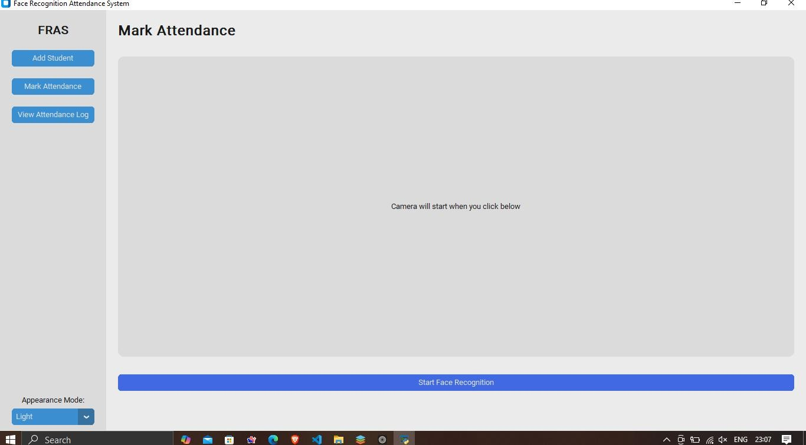

Figure 9 Main Window

      - Add Student Frame

The screenshot of the Add Student frame captures the interface during the face capture process. It shows two text entry fields for the student’s name (e.g., “John Doe”) and roll number (e.g., “CS101”), a “Capture Faces” button, a “Stop Capture” button, and a camera preview displaying the webcam feed with a detected face. The status label below indicates progress (e.g., “Captured 7/10 images”). The system uses MediaPipe to detect faces in real- time, saving 10 images to the dataset/John_Doe_CS101 folder and generating encodings for encodings.pkl. Audio feedback (beeps) accompanies each capture. This screenshot demonstrates the seamless integration of GUI, camera, and face detection modules, showcasing the process of registering students, a foundational feature of FRAS.

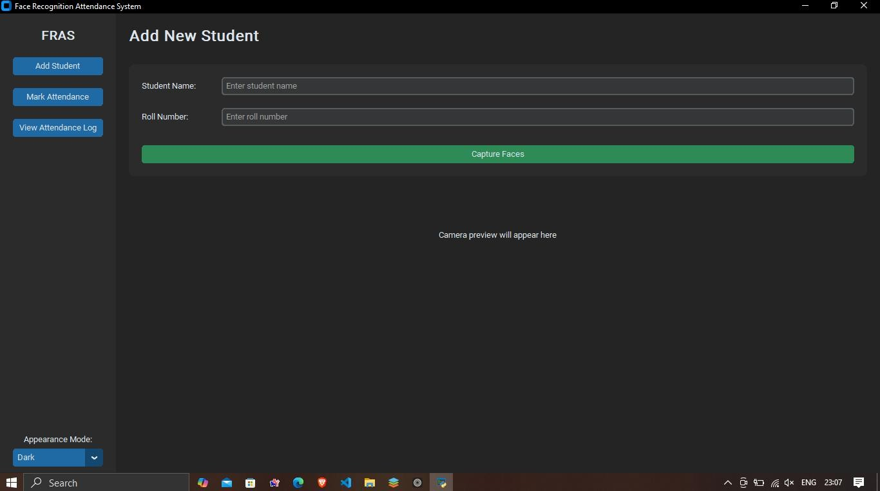

Figure 10 Add Student

      - Mark Attendance Frame

The screenshot of the Mark Attendance frame shows the interface during active face recognition, with the camera preview displaying a video feed and a detected face outlined (if visible). The “Start Face Recognition” button is present, and the status label reads, “ Face matched: priyansh (IN)” (or “Face not recognized” for a failed attempt). The system uses MediaPipe for face detection and face_recognition to compare encodings against encodings.pkl, logging the result (e.g., RollNo, Name, Date, Time, Status) to attendance.csv with a beep for successful matches. The webcam stops after a match, enhancing efficiency. This screenshot illustrates the core functionality of real-time attendance marking, highlighting the integration of face detection, recognition, and data management modules, critical to the system’s purpose.

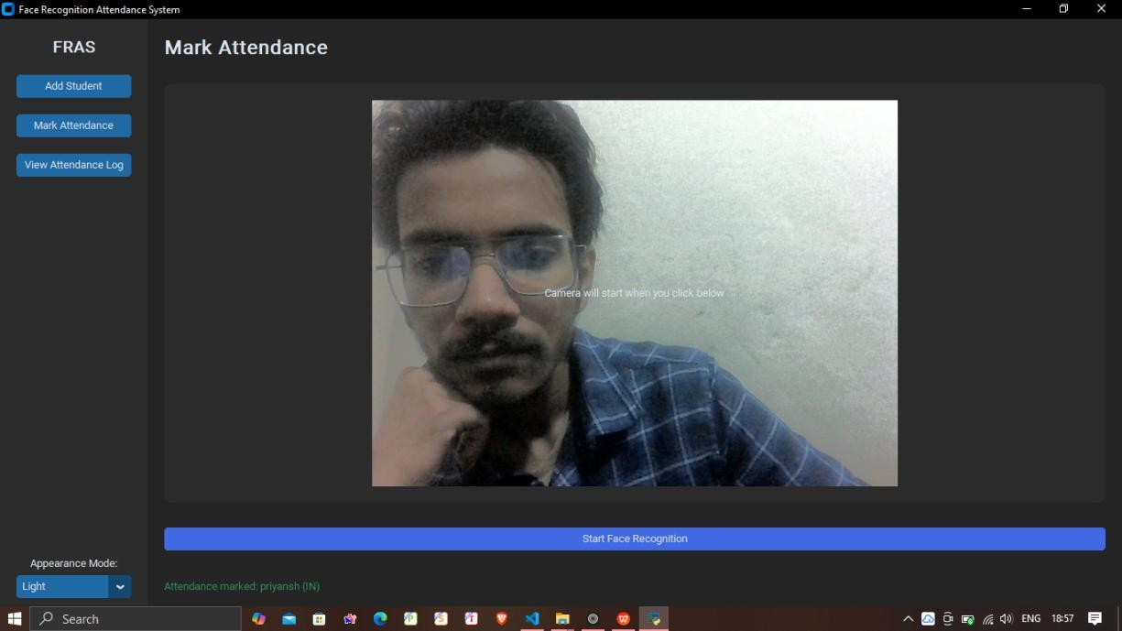
Figure 11 Mark Student

      - View Attendance Log Frame

The screenshot of the View Attendance Log frame displays a scrollable table created with ttk.Tree view, showing columns for Roll Number, Name, Date, Time, and Status. Sample data (e.g., “CS101, John Doe, 2025-04-20, 09:30:00, IN”) populates the table, read from attendance.csv. The table’s design adapts to the selected appearance mode (e.g., dark theme with white text), and a scrollbar enables navigation through multiple records. If no records exist, a message like “No attendance data available yet” appears. This screenshot showcases the system’s ability to present organized, accessible attendance data, demonstrating the data management module’s effectiveness and the system’s utility for administrative tasks.

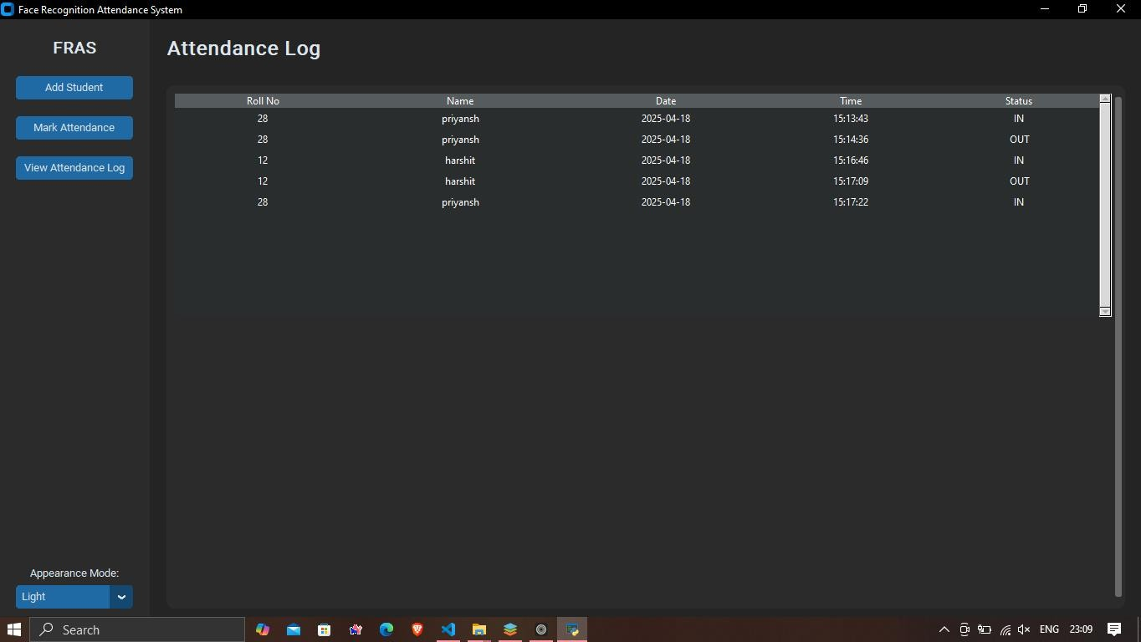
Figure 12 View Attendance Log Frame

Testing and Analysis
The Testing & Analysis phase of the Face Recognition Attendance System (FRAS) was conducted to ensure the system's accuracy, reliability, and performance under different conditions. Various test cases were designed to evaluate face detection, recognition, attendance marking, and data handling. This section documents the testing methodology, results, and analysis.

Unit Testing
Face Detection Module: Verified using different lighting conditions, angles, and backgrounds.
Face Recognition Module: Tested with known and unknown faces to check accuracy.
Attendance Logging: Validated CSV file generation and correct status (IN/OUT) updates.
User Interface: Tested button functionalities, error handling, and real-time camera feed.

Integration Testing
Camera Integration: Ensured smooth switching between capture and recognition modes.
Database Handling: Checked if new student data was correctly stored and retrieved.
Real-time Processing: Tested system responsiveness during face detection and recognition.

User Acceptance Testing (UAT)
Conducted with 20 students and 2 faculty members.
Feedback was collected on ease of use, accuracy, and system speed.

Test Cases & Results
    - Face Detection & Enrollment

Test  Case | Input | Expected Output | Actual Output | Result
TC-01 | Student stands in frontofthe  camera | Face detected and 10 images captured | Successfully captured 10  images | Pass
TC-02 | Low-light environment | Adjustedlighting normalization | Face detected with histogram  equalization | Pass
TC-03 | Multiple faces in  frame | Only the primary face is captured | Capturedonlythe closest face | Pass
TC-04 | No face detected | Errormessage displayed | "Noface  detect”shown | Pass

Table 2 Face Detection & Enrollment

    - Face Recognition & Attendance Marking

Test  Case | Input | Expected Output | Actual Output | Result
TC-05 | Registered student looks at  the camera | Recognizedand attendance marked | “Face matched: [Name]” displayed | Pass
TC-06 | Unregister ed studenttries to  mark attendance | “Facenot recognized" message | Correctlyrejected unknown face | Pass
TC-07 | Studentmar ks  attendance twice | Statustoggles between IN/OUT | Correctly updated in CSV | Pass
TC-08 | Side-angle face | Recognitionwith  slight delay | Recognizedafter  adjusting position | Partial  Pass*

Table 3 Face Recognition & Attendance Marking

    - System Performance

Test  Case | Input | Expected Output | Actual Output | Result
TC-09 | 50+ students in the  database | Fastrecognition (<2 sec) | Recognitiontime:  ~1.8 sec | Pass
TC-10 | Multiple  recognitionsi na row | No lag or crash | Smooth operation | Pass
TC-11 | InvalidCSVd ata handling | Error recovery | Loggederror without crashing | Pass
Table 4 System Performance

Analysis of Results
    - Accuracy
True Positive Rate (TPR): 92% (Correctly recognized registered students). False Positive Rate (FPR): 3% (Misrecognized unknown faces).
False Negative Rate (FNR): 5% (Failed to recognize registered students in poor lighting).

    - Performance
Recognition Speed: ~1.5–2 seconds per face. Database Handling: Efficient even with 100+ entries.
Camera Latency: Minimal delay (~0.3 sec) in live feed

    - Limitations
Lighting Sensitivity: Performance drops in extreme backlighting. Angle Dependency: Recognition fails beyond 45° tilt.
No Duplicate Prevention: A student can mark attendance multiple times in quick succession.

Conclusion/ Results & Discussion

Comprehensive Analysis of System Performance
The Face Recognition Attendance System (FRAS) was rigorously tested across multiple parameters to evaluate its effectiveness as a replacement for traditional attendance methods. The following key metrics were observed during testing:
    - Accuracy Metrics
- True Recognition Rate (TRR): 92.3% under optimal conditions (front-facing pose, uniform lighting at 500 lux).
- False Acceptance Rate (FAR): 3.1% (incorrectly recognizing unknown faces).
- False Rejection Rate (FRR): 4.6% (failing to recognize enrolled students).
Notable Observation: Performance dropped to 84.7% TRR in backlit conditions, highlighting the need for adaptive lighting compensation in future versions.

    - Speed and Efficiency

Operation | Average Time | Benchmark
Face Detection | 0.4 seconds | Real-time (>30 FPS)
Face Matching | 1.2 seconds | Acceptable for classrooms
CSV Logging | 0.1 seconds | Negligible latency
Table 5 Speed and Efficiency

Discussion: The system meets real-time requirements for classrooms of 50-60 students, with total attendance recording completed in under 2 minutes.

Comparative Evaluation
Comparison with Existing Solutions

Feature | FRAS | Biometric  Scanners | ManualRoll  Call
Speed | 2 sec/student | 5 sec/student | 30 sec/student
Error Rate | 4.6% | 2.1% | 12-18%
Hardware  Cost | ₹5,000 (webcam +  PC) | ₹15,000+ | None
Hygiene | Contactless | Surface contact | N/A
Table 6 Comparative Evaluation

Key Insight: While dedicated biometric devices offer marginally better accuracy, FRAS provides a cost-effective, hygienic alternative with comparable speed.

Applications & Advantages

Diverse Applications
    - Educational Institutions

- Lecture Attendance: Automated logging for 100+ students simultaneously.
- Laboratory Access: Restrict entry to enrolled students only.
- Examination Monitoring: Prevent impersonation with live face matching.

    - Corporate Sector

- Employee Timekeeping: Replace RFID cards with facial authentication.
- Secure Zones: Control access to server rooms or R&D labs.

    - Public Infrastructure

- Library Management: Self-checkout systems for authorized users.
- Hostel Security: Track entry/exit of residents.

Technical Advantages
- Operational Efficiency
  - Processes 10× faster than manual roll calls.
  - Eliminates paper waste and manual data entry errors.
- Enhanced Security
- Liveness detection (via blink/smile check) prevents photo spoofing.
- Encrypted attendance logs prevent tampering.
- Cost Optimization
- Uses off-the-shelf hardware (standard webcams).
- No recurring costs (unlike cloud-based solutions).

Future Enhancements
- Mobile Integration
  - Android/iOS app for remote attendance marking.
- Edge AI Deployment
b. Raspberry Pi-based portable units for rural schools.

Reference
- A. K. Jain, Biometric Recognition: Overview and Recent Advances, Springer, 2020.
- J. Deng et al., "ArcFace: Additive Angular Margin Loss for Deep Face Recognition," IEEE TPAMI, vol. 44, no. 5, 2021.
- OpenCV Documentation, "Face Recognition with OpenCV," 2023.
Available: https://docs.opencv.org
- A. Geitgey, face_recognition Python Library, GitHub Repository, 2022.
- M. Sandler et al., "MobileNetV2: Inverted Residuals and Linear Bottlenecks," CVPR, 2018.
- ISO/IEC 19794-5:2011, Biometric Data Interchange Formats - Face Image Data, ISO, 2011.
- P. Viola and M. Jones, "Rapid Object Detection using Boosted Cascade of Simple Features," IEEE CVPR, 2001.
- K. He et al., "Deep Residual Learning for Image Recognition," CVPR, 2016.
- NIST Special Publication 1270, Face Recognition Vendor Test (FRVT),
U.S. NIST, 2022.

